**System Monitoring with Nagios**

* Nagios is a popular tool for System Monitoring
* System monitoring in Nagios is split into two categories
  + hosts: Represent physical or virtual device (server, router, printer)
  + services: Represents particular functionality of hosts (ssh, http)

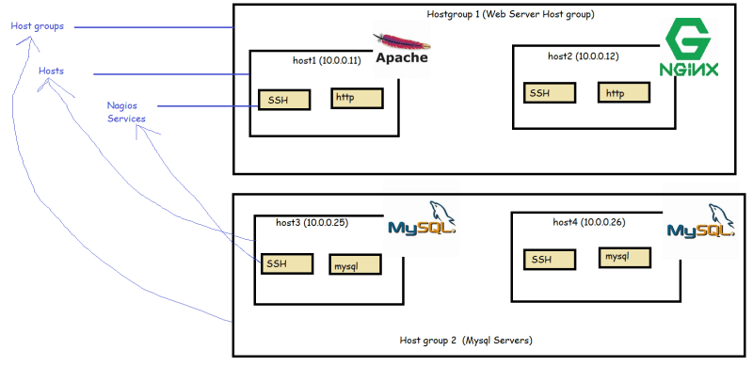

* Host groups are logical collection of hosts
* In Nagios when we perform checks it uses four states
  + Ok
  + Warning
  + Critical
  + UnKnown
* To collect the States for the Checks Nagios uses plugins
* Nagios performs all of its checks using plugins. These are external components for which Nagios passes information on what should be checked and what are warning, critical and ok limits are.
* Plugins are responsible for performing the checks and analyzing results. The output from check is status.
* Nagios provides set of standard plugins that allow performance checks for almost all the services. Moreover if you need to perform a specific check, Nagios provides an approach to write your own plugins in any language.

**Main features**

* Nagios Main strength is flexibility, It has a mechanism to react automatically to problems and a powerful notification system.
* For this flexibility is based on object definition system
* The object definitions are based on few types of objects
  + Commands
  + Time periods
  + Hosts and Host Groups
  + Services
  + Contacts and Contact Groups
  + Notifications

**Soft and hard states**

* A service is down for a very short time or the test is temporarily failed etc are the normal failures
* When a previous state of check is different from the current one (Critical), Nagios will re test the host or service for a couple of times to make sure change is permanent. Nagios assumes the new result is soft-state, after additional test have verified that the new state is permanent, it is considered to be hard state.